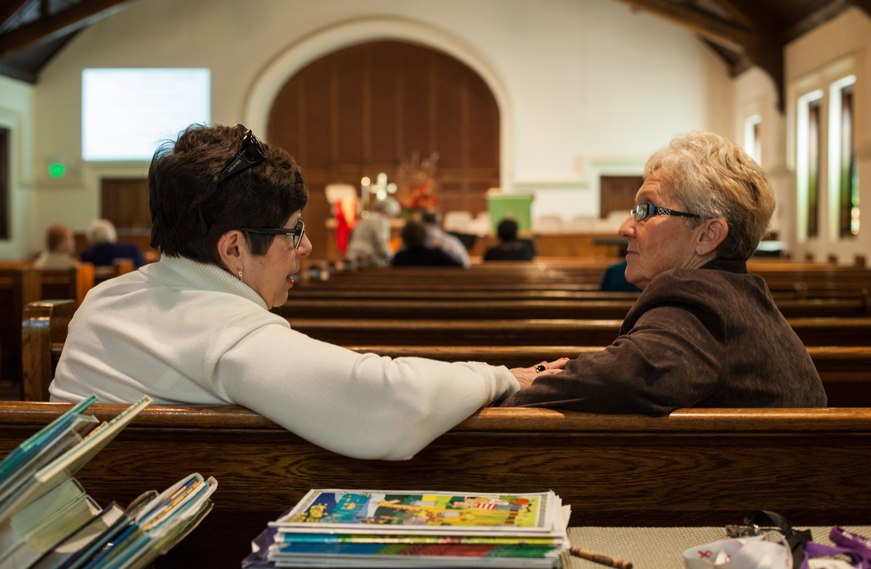 | STONE CHURCH OF THE BRETHREN  Church Use Contract  General Building Usage Juniata College

Event Primary Information
Date of Event: Click or tap to enter a date.
Event Title: Click or tap here to enter text.
Event Start Time: Choose an item. | Estimated End Time: Choose an item.
Set-Up Start Time: Choose an item. | Estimated Clean-Up Completion: Choose an item.
Do you require the day before to prepare? Yes ☐ No ☐
Purpose of Function: Click or tap here to enter text.

Contact Information
Group/Club Name: Click or tap here to enter text.
Contact Person: Click or tap here to enter text.
Phone: Click or tap here to enter text. | Email: Click or tap here to enter text.
You are responsible for your own set-up, including furniture. And any areas used should be returned to the order in which they were found. As part of our call to good stewardship of our resources, we provide use of the facility and available equipment to you free of charge; but charge a small fee to cover the cost of the tablecloths (when used) and any cleaning staff must do following your event (should this be necessary, we will advise you of the fee due).

Event Secondary Information (Logistics)
Number of persons expected to use building: Click or tap here to enter text.
Do you have a preferred room? If so, which one(s)?: Choose an item. and/or Choose an item.
What equipment will you be using: (tables, chairs, tablecloths, TV, microphone/sound, projector):
Click or tap here to enter text.
Person responsible for clean-up (if different than contact person):
Name: Click or tap here to enter text. Phone: Click or tap here to enter text.
Date of Application: Click or tap to enter a date.
Submission of the form constitutes agreement to the Building Use terms.

